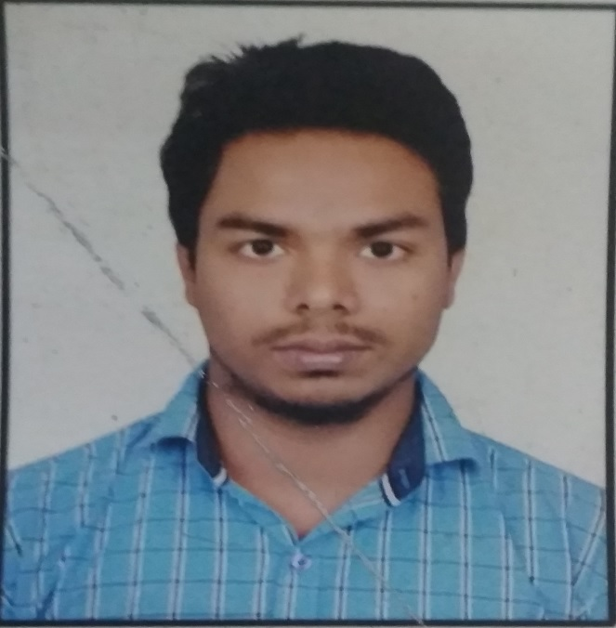

**SONAL KUMAR ROY**

#414-B, Le Corbusier Boys Hostel, Chandigarh University,

Gharuan, Mohali-140413.

+91-9779993488

Sonalroy616@gmail.com

**CAREER OBJECTIVE**

To be associated with a firm,that provide carrier development opportunitiesand to contribute in its progress through my knowledge and skill.

**EDUCATIONAL QUALIFICATIONS**

|  |  |  |  |  |
| --- | --- | --- | --- | --- |
| **Degree** | **School/ Institute** | **Board/University** | **Percentage** | **Year of passing** |
| B.E (C.S.E) | University Institute of Engineering | Chandigarh University | 7.8(till 6thSem) | 2019 |
| 12th | Gyan bharti vidyapith | West Bengal board | 63% | 2014 |
| Matriculation | Eastern railway hindi high School | West Bengal board | 69% | 2012 |

**SOFTWARE COMPETENCIES**

|  |  |  |
| --- | --- | --- |
| Operating Systems | : | Microsoft Windows |
| Languages | : | Java and , C++, C  Elementary knowledge in HTML |
| Database | : | Oracle , SQL |
| Others | : | Operating System ,Software Engineering , Relational Database |

**PROJECTS**

|  |  |  |
| --- | --- | --- |
| Project Name : **Chat server(during training)** | | |
| Environment | : | eclipse, |
| Language | : | Java |
| Project Description | : | It helps in conversation between two people |

|  |  |  |
| --- | --- | --- |
| Project Name : **java based game** | | |
| Environment | : | Eclipse |
| Language | : | Java |
| Project Description | : | It was a java based gamecalled brick breaker for entertainment |

**INDUSTRIAL TRAINING**

* Studied basics of Data Structures and C++ for 1 month at Chandigarh University from May 2016 to June 2016..
* 6 weeks industrial training in java from Excellence technology from May 2017 to July 2017..

**INTRAPERSONAL SKILLS**

* Leadership Skills
* Optimistic
* Interactive
* Quick learner

**EXTRA-CURRICULAR ACTIVITIES**

* Member of organizing committee of university level talent hunt.
* Hosted an event (Escape challenge)in university TechInvent for consecutively two years.

**HOBBIES/INTERESTS**

* Playing Computer Games
* Watching Movies
* Exploring Nature, Travelling
* Listening Songs
* Writing shayari

**PERSONAL INFORMATION**

**Date of Birth** : 4thnovember 1995

**Sex / Marital Status** : Male / Single

**Father’s Name** : Mr. Suresh kumar roy

**Mother’s Name** : Mrs.Renu devi

**Language Proficiency** : English, Hindi.

**DECLARATION**

**I do hereby declare that all the information given above is true to the best of my knowledge and belief.**

**Place : Punjab**

**Campus Contact**



Gharuan, Mohali - 140413 (Punjab), India

Phone : 0160-3014402

Email **:**placementinfo@cumail.in